6) ip.dst == 184.171.153.94

8a) Destination: IETF-VRRP-VRID_6d (00:00:5e:00:01:6d)

8b) Source: Dell_37:28:e1 (60:5b:30:37:28:e1)

9a) Destination Address: 162.241.216.188

9b) Source Address: 184.171.153.94

10a) Destination Port: 80

10b) Source Port: 63534

10c) 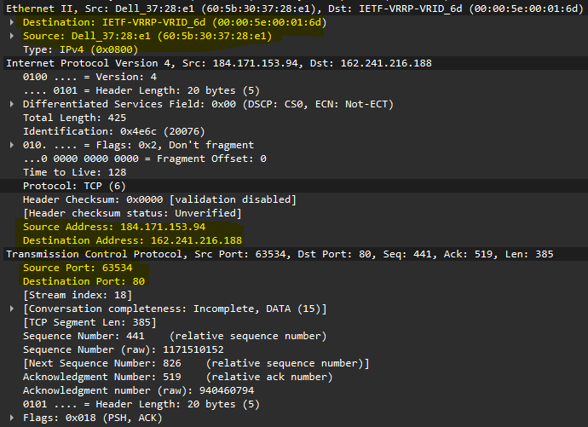

12) MAC addresses, IP addresses, and ports undergo swapping between the request and return packets. The source and destination MAC addresses switched between my device and the destination device. Similarly, my device's IP became the source IP in outgoing packets and the destination IP in incoming packets. The Port numbers also changed between my device and the destination device.